Albert José-Antonio López

Massachusetts Institute of Technology

**Pedro Martínez Inclán (1883, Cienfuegos - 1957, Havana), Architect, Urbanist**

The urban development of modern Havana and the emergence of a planning discourse in Cuba owes much of its existence to the efforts of architect, urbanist, and professor Pedro Martínez Inclán. Through his authorship of urbanist texts and discussions widely disseminated amongst the local profession, his position as a reformer through his involvement in such influential institutions as the Patronato Pro-Urbanismo (*Pro-Urbanism Foundation*), and his role as a pedagogue to a generation of young modernists, Martínez Inclán may be regarded as one of the most important figures in the genesis of a school of Cuban regional modernity, and more importantly a locally contextualized functional urbanism.

A native of Cienfuegos, Cuba, Pedro Martínez Inclán emigrated to the nation’s capital in 1899, eventually beginning his studies in architecture at the University of Havana’s School of Engineers and Architects. Graduating from said institution in 1910, he joined the profession and from 1913 to 1933 held the position of municipal architect of Havana. He was responsible for the first Plan Director de La Habana(*Master Plan of Havana*) during the presidential administration of Mario García Menocal (1913-1921), and in 1925 published a book on his views on urban design and beautification including a hypothetical 100-year design projection for a future Havana ironically titled *La Habana Actual* (*Current Havana*)*.* His claims that Havana’s beautification was to go hand in hand with a renewal in arterial infrastructure through broad avenues and parks predated the involvement of French planner and landscape architect Jean-Claude Forrestier, who visited Cuba extensively and produced a body of planned work for the island’s capital between 1925 and 1930.

In 1942, Martínez Inclán initiated a public campaign to promote urbanism and the adoption of a national planning law by co-founding the Patronato Pro-Urbanismo. This organization, composed of architects, planners, economists, lawyers, and the most esteemed intellectuals in Cuba during the time, sought a legal framework and corresponding governing body directed at promoting the cooperation of a broad range of Cuban institutions in planning its cities, economic regions, and the nation as a whole. Aside from the effects that this institution had on progressive planning efforts, it also contributed to the growing interest in historical preservation.

During the government of Ramón Grau San Martín (1944-1948) Martínez Inclán served as an advisor to the Ministry of Public Works, contributing to the design of the Barrio Obrero de Luyanó(*Worker’s Neighborhood of Luyanó,* 1948) along with architects Mario Romañach and Antonio Quintana. During this time he also served as the President of the College of Architects, the main professional organization for architecture in Cuba.

Martínez Inclán contributed in disseminating CIAM theory in a hybridized fashion with his publication of the Carta de La Habana(*Havana Charter*) – an adaptation of the Athens Charter of 1943 – at the first National Congress of Architecture held in Havana in 1948. Although it supported the basic concepts of the original document, including its four functions of dwelling, work, recreation and transport, this document can be understood as a critique of the international and essentially placeless nature of the CIAM urban framework. Attention to climate and tradition are evident, particularly in its recommendations on street organization and dimension as well as its considerations toward an urban aesthetic that acknowledged the role of historical architectural patrimony. This document was republished for the VII Pan-American Congress of Architects held in Havana in 1950, and would continue to influence the planning efforts of that city throughout the decade.

As a professor at the University of Havana, Martínez Inclán acted as a reformer, urging for the traditionally conservative School of Architecture to expand its academic focus and train its students in urbanism. During his tenure at the university he founded, along with architect Eduardo Cañas Abril, a department in the Architecture of Cities, Parks, and Gardens, and would also propose the development of a School of Urban and Rural Planning based on the Institute of Urbanism at the Sorbonne. He supported the modernizing efforts of his students, many of whom incorporated themselves into ATEC (Agrupación Tectónica de Expresión Contemporánea). Although not directly involved with its organization, his efforts would be carried on by many of these younger architects and planners as they formed the first national planning board, the Junta Nacional de Planificación(*National Board of Planning*, or JNP), in 1955.

Further Reading:

Gómez Díaz, Francisco (2008) *De Forestier a Sert: ciudad y arquitectura en La*

*Habana de 1925 a 1960,* Madrid: Abada Editores, S.L.

Hyde, Timothy (2012) *Constitutional Modernism: Architecture and Civil Society 1933-1959,* Minneapolis: University of Minnesota Press.

Segre, Roberto (February-March 2010) “Pedro Martínez Inclán: Primer Urbanista Cubana (I-VI)” *Arquitectura Cuba.* <http://arquitectura-cuba.blogspot.com>

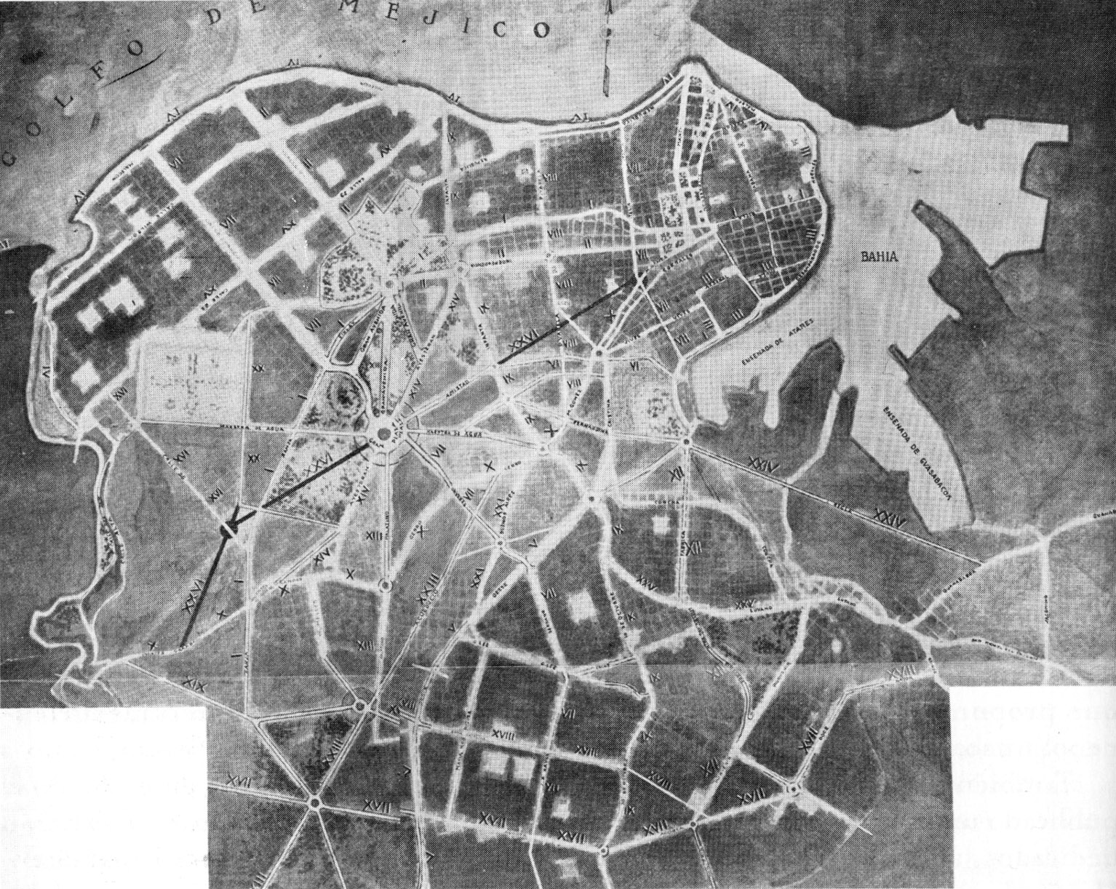

Network of avenues and parks proposed by Martínez Inclán in *La Habana Actual,* 1925. (Image in *De Forestier a Sert,* pg 44. Image originally in *La Habana Actual.*)

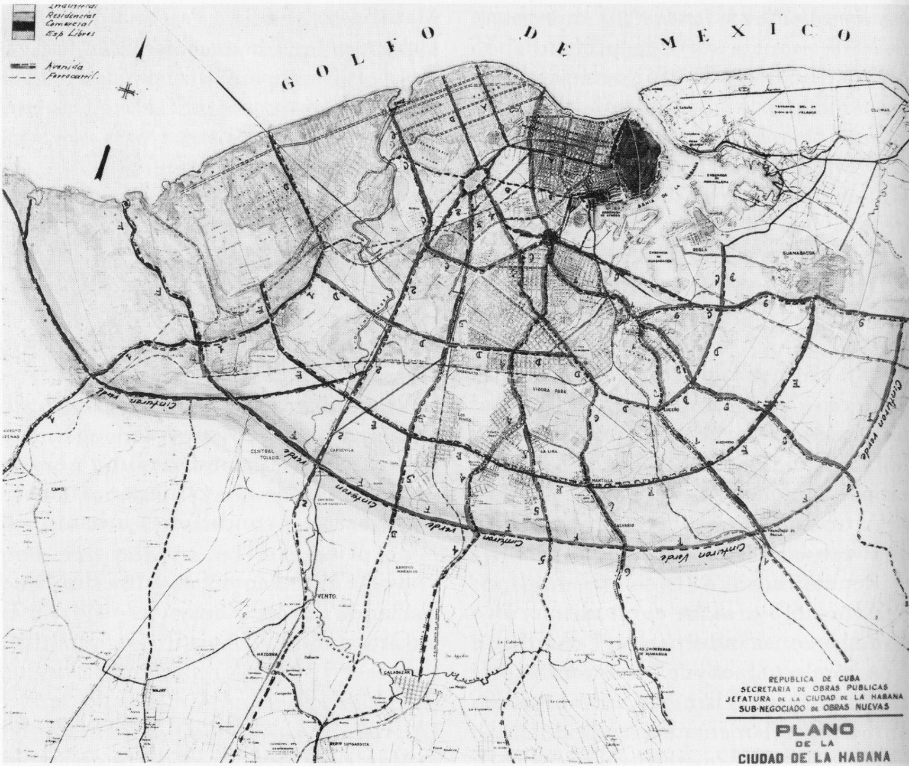

New system of traffic circulation for Havana proposed by the Ministry of Public Works in 1945. (Image in *De Forestier a Sert,* pg 100. Author credits image as belonging to the Archive of Juan de las Cuevas)

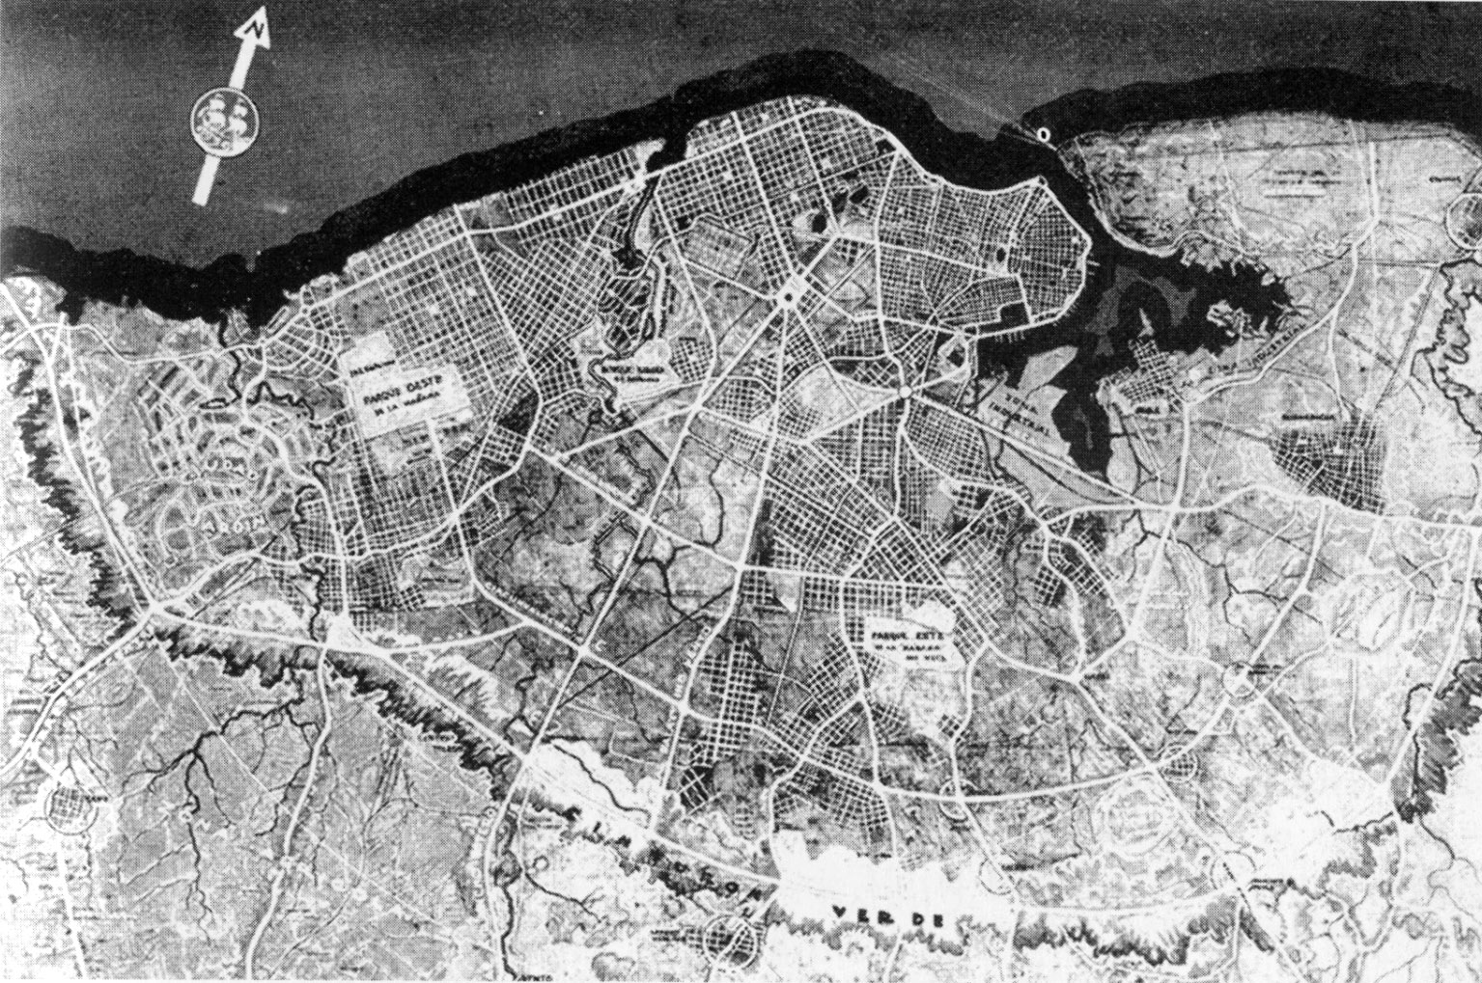

Master Plan of Havana by the Ministry of Public Works, coordinated by Martínez Inclán with system of traffic circulation, 1946. (Image in *De Forestier a Sert,* pg 105. Author credits image as being originally published in *Arquitectura*)

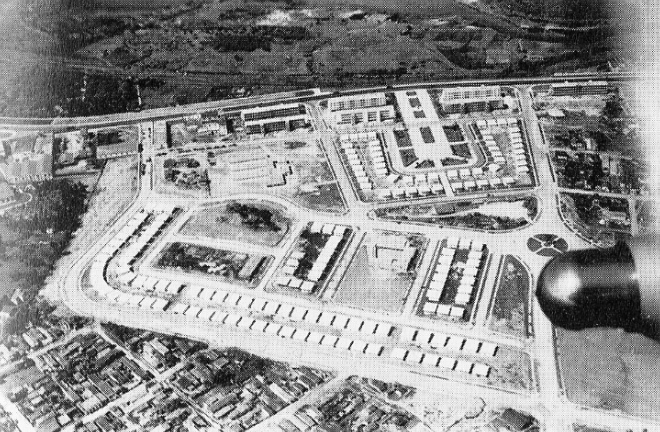

Aerial view of Barrio Obrero de Luyanó by Martínez Inclán, Mario Romañach, Antonio Quintana, and Jorge Mantilla, 1948. (Image in *Havana Guide,* pg 219. Author credits image as “Archival.”)